ultramirinc.champs_mood.fragments

Class MyViewHolderNotification

java.lang.Object

android.support.v7.widget.RecyclerView.ViewHolder ultramirinc.champs_mood.fragments.MyViewHolderNotification



public class MyViewHolderNotification

extends android.support.v7.widget.RecyclerView.ViewHolder

Created by William on 2017­04­06. This class makes the transition between the raw data and a visual interpretation for the user's notifications.

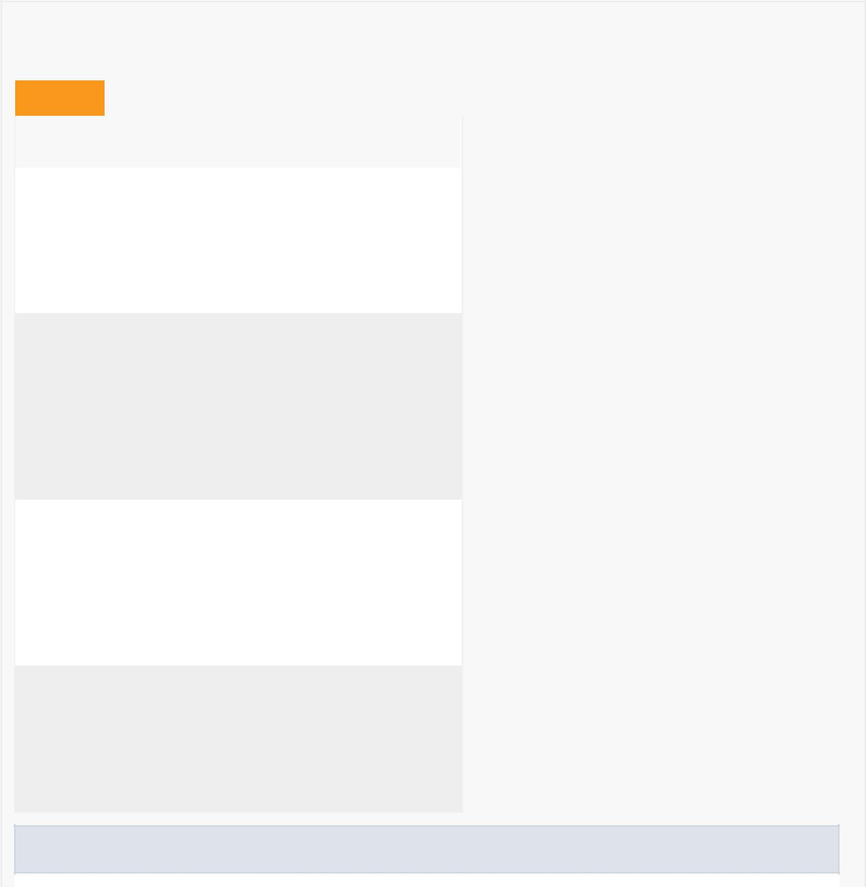

*Field Summary*

Fields

|  |  |
| --- | --- |
| Modifier and Type | Field and |
|  | Description |
| private android.widget.Button | button |
|  | Contains the |
|  | Button of the |
|  | person that |
|  | sent the |
|  | notification |

private android.widget.TextView isFriendView

Contains the TextView of the friend status of the person that sent the notification

private android.widget.TextView sentByView

Contains the TextView of the name of the person that sent the notification

private android.widget.TextView typeView

Contains the TextView of the notification's type

Fields inherited from class android.support.v7.widget.RecyclerView.ViewHolder

itemView

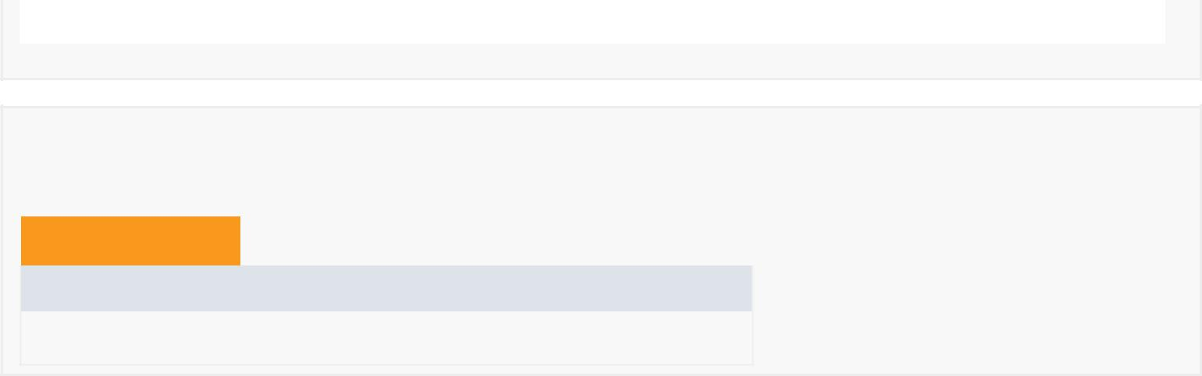

*Constructor Summary*

Constructors

Constructor and Description

MyViewHolderNotification(android.view.View itemView)

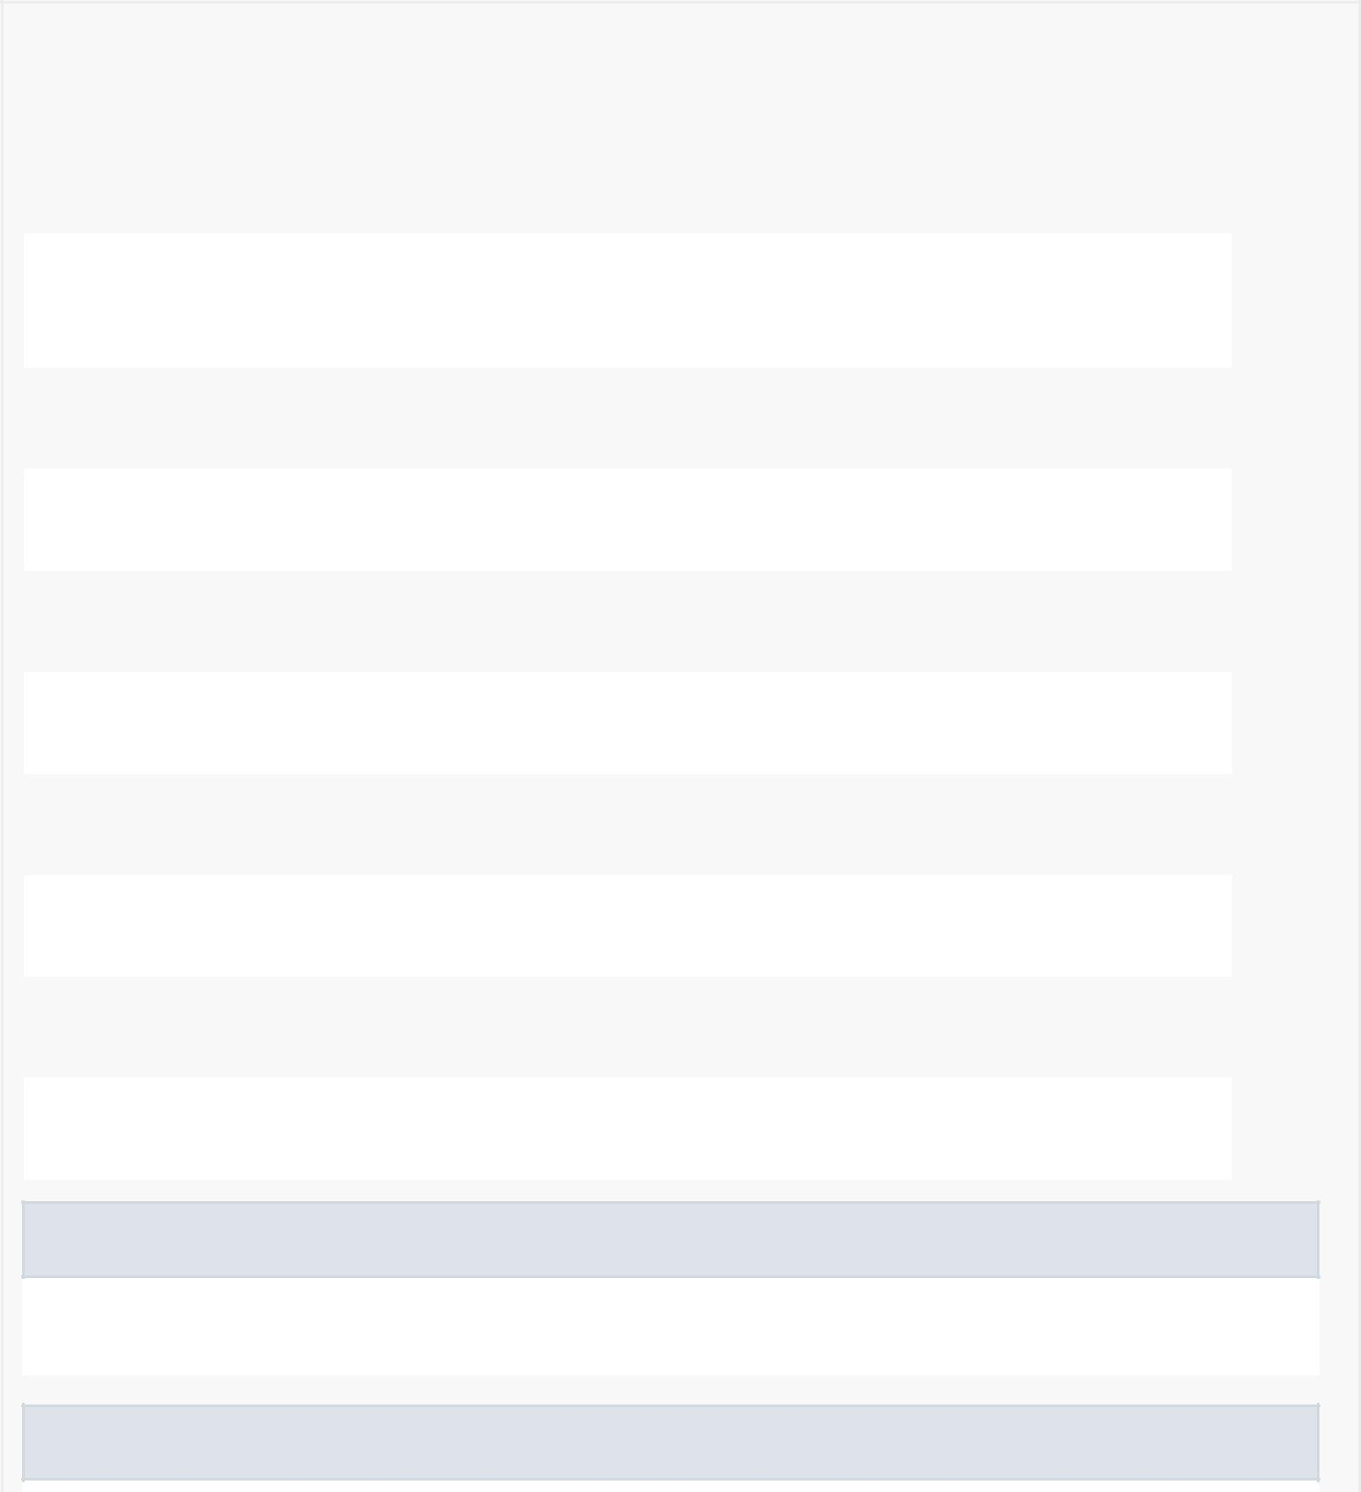

|  |  |  |  |  |  |  |  |  |  |
| --- | --- | --- | --- | --- | --- | --- | --- | --- | --- |
| *Method Summary* | | | | |  |  |  |  |  |
|  |  | |  |  | |  |  |  |  |
|  | All Methods |  |  | [Instance Methods](javascript:show(2);) | |  |  | [Concrete Methods](javascript:show(8);) |  |
|  | Modifier and Type | | |  | Method and Description | | | | |
|  | void | | |  | bind(Notification notification) | | | | |
|  |  |  |  |  | Binds the notifications's person name, type and person friend | | | | |
|  |  |  |  |  | status to their respective TextView variables. | | | | |
|  |  |  |  | |  |  |  |  |  |
|  | android.widget.Button | | | | getButton() | | |  |  |
|  |  |  |  |  | Getter for button. | | | | |
|  | android.widget.TextView | | | | getIsFriendView() | | | | |
|  |  |  |  |  | Getter for isFriendView. | | | | |
|  |  |  |  | |  |  |  | |  |
|  | android.widget.TextView | | | | getSentByView() | | | | |
|  |  |  |  |  | Getter for sentByView. | | | | |
|  | android.widget.TextView | | | | getTypeView() | | | | |
|  |  |  |  |  | Getter for typeView. | | | | |
|  |  |  |  |  |  |  |  | |  |
|  | void | | |  | setButton(android.widget.Button button) | | | | |
|  |  |  |  |  | Setter for button. | | | | |
|  | void | | |  | setIsFriendView(android.widget.TextView isFriendView) | | | | |
|  |  |  |  |  | Setter for isFriendView. | | | | |
|  |  |  |  |  |  |  |  | |  |
|  | void | | |  | setSentByView(android.widget.TextView sentByView) | | | | |
|  |  |  |  |  | Setter for sentByView. | | | | |
|  | void | | |  | setTypeView(android.widget.TextView typeView) | | | | |
|  |  |  |  |  | Setter for typeView. | | | | |
|  |  |  |  |  |  |  |  |  |  |

Methods inherited from class android.support.v7.widget.RecyclerView.ViewHolder

getAdapterPosition, getItemId, getItemViewType, getLayoutPosition, getOldPosition, getPosition, isRecyclable, setIsRecyclable, toString

Methods inherited from class java.lang.Object

clone, equals, finalize, getClass, hashCode, notify, notifyAll, wait, wait, wait

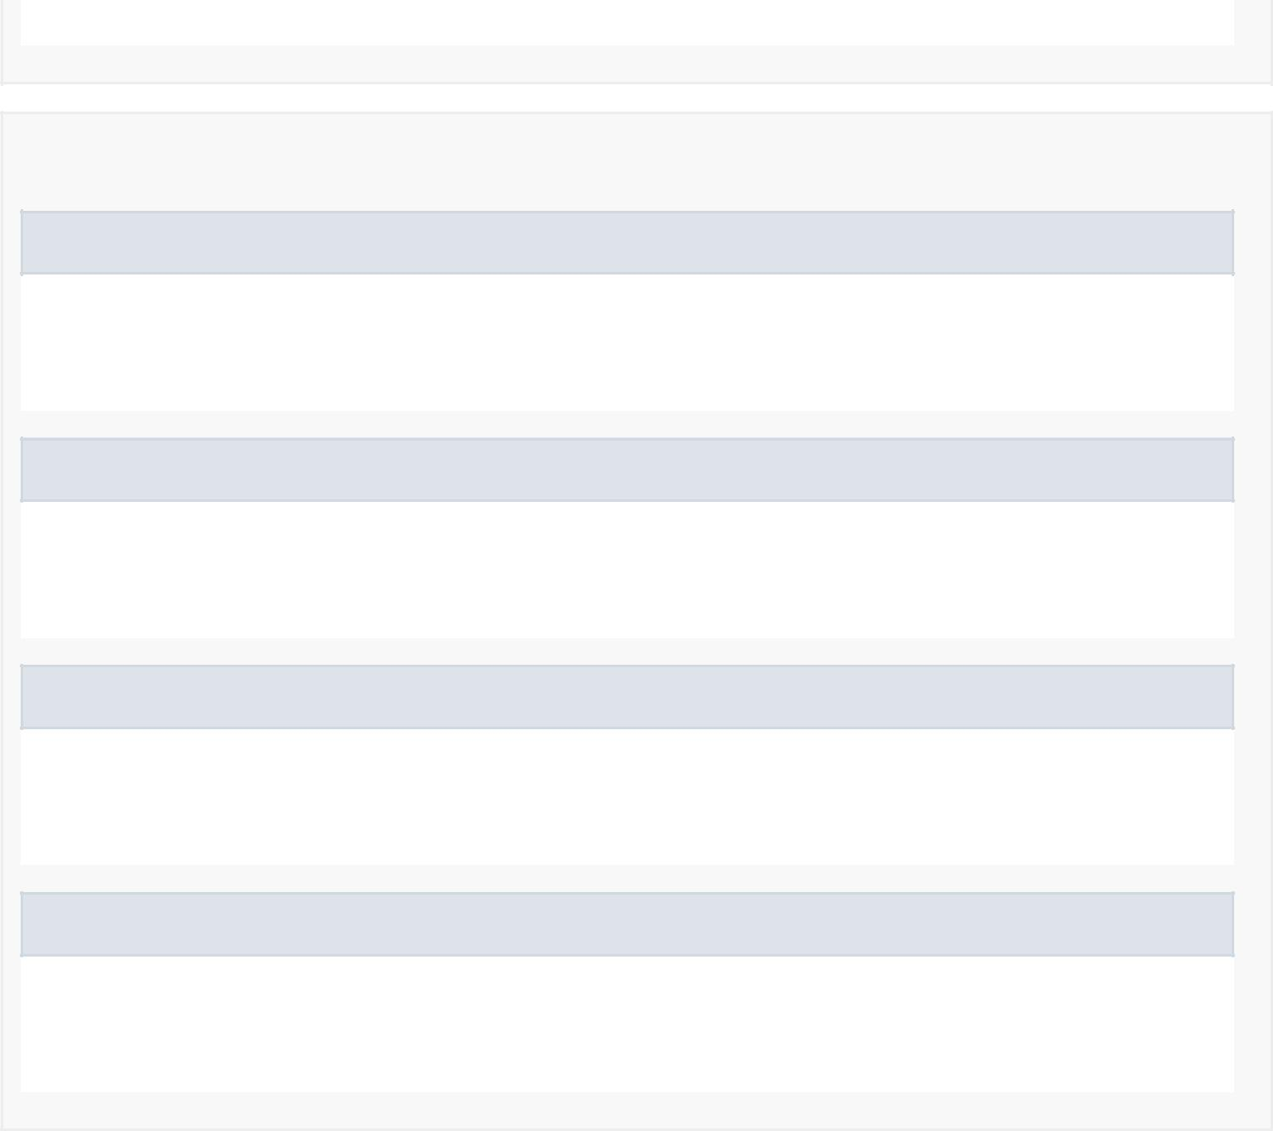

*Field Detail*

button

private android.widget.Button button

Contains the Button of the person that sent the notification

sentByView

private android.widget.TextView sentByView

Contains the TextView of the name of the person that sent the notification

typeView

private android.widget.TextView typeView

Contains the TextView of the notification's type

isFriendView

private android.widget.TextView isFriendView

Contains the TextView of the friend status of the person that sent the notification

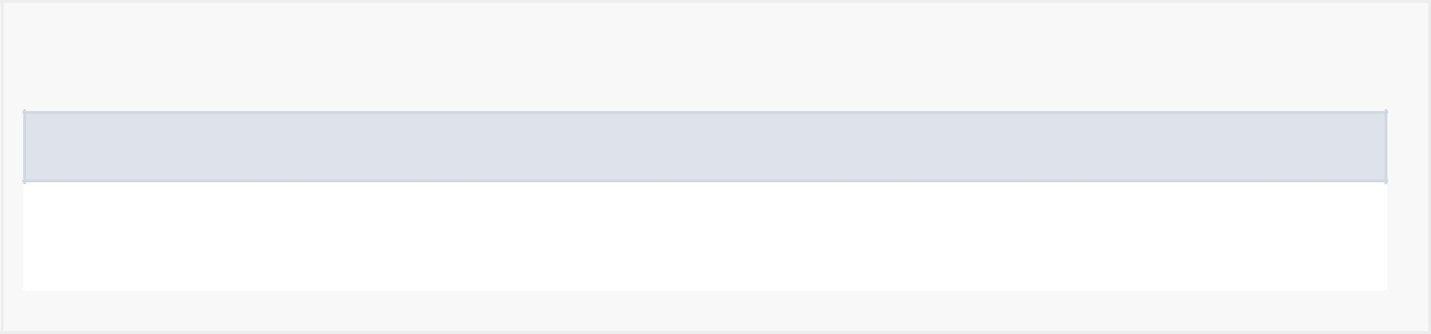

*Constructor Detail*

MyViewHolderNotification

public MyViewHolderNotification(android.view.View itemView)

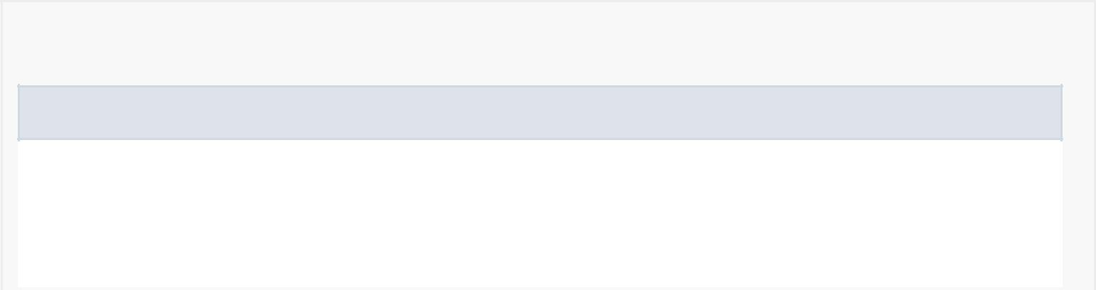

*Method Detail*

bind

public void bind(Notification notification)

Binds the notifications's person name, type and person friend status to their respective TextView variables.

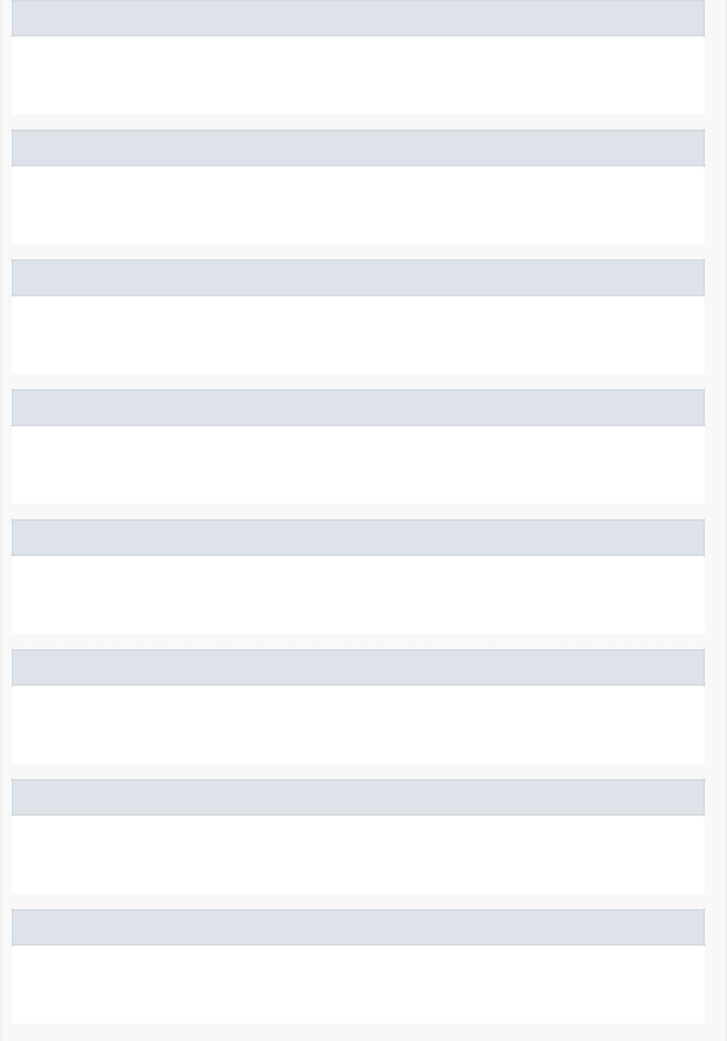getSentByView

public android.widget.TextView getSentByView()

Getter for sentByView.

setSentByView

public void setSentByView(android.widget.TextView sentByView)

Setter for sentByView.

getTypeView

public android.widget.TextView getTypeView()

Getter for typeView.

setTypeView

public void setTypeView(android.widget.TextView typeView)

Setter for typeView.

getIsFriendView

public android.widget.TextView getIsFriendView()

Getter for isFriendView.

setIsFriendView

public void setIsFriendView(android.widget.TextView isFriendView)

Setter for isFriendView.

getButton

public android.widget.Button getButton()

Getter for button.

setButton

public void setButton(android.widget.Button button)

Setter for button.

